St. Francis Xavier Catholic Church invites the faith community to join them in their
40hrs Devotion

Sunday June 4th – Tuesday, June 6th

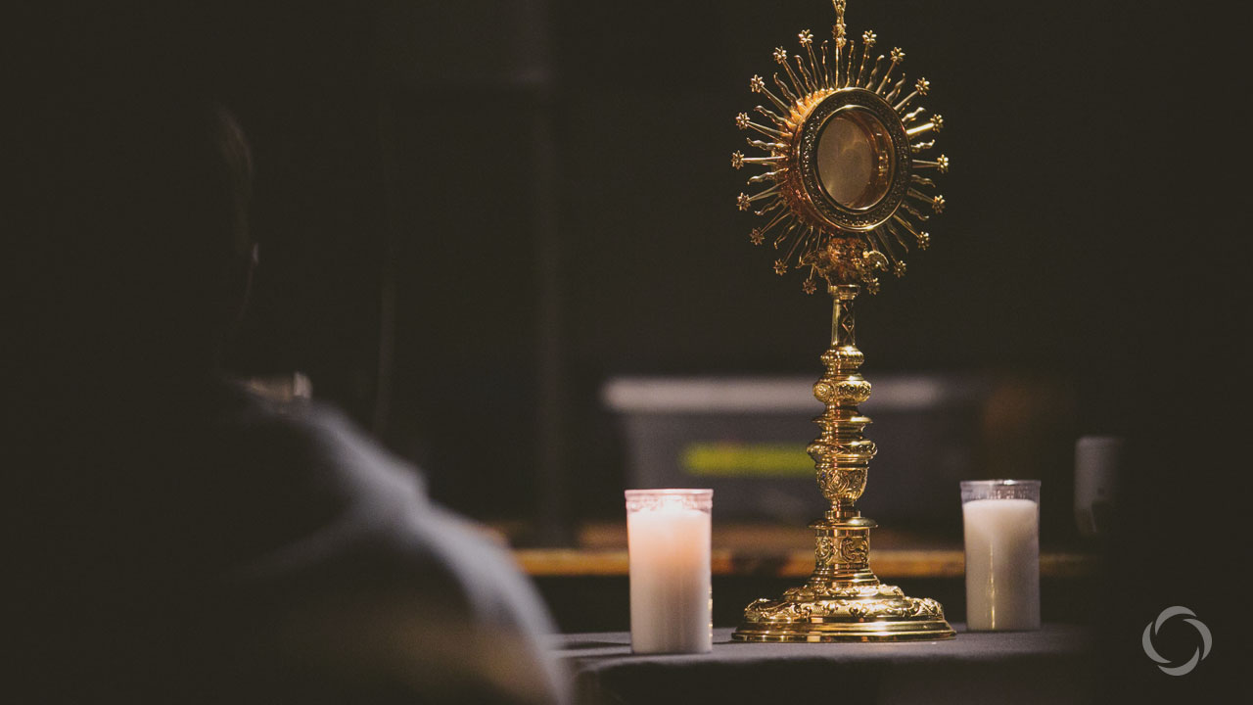

Each of the 3 days will begin with morning Mass. The following hours will be filled with Adoration, light refreshments, and talks on the Blessed Sacrament by Msgr Robert C. Shultz & Fr. Glenn J. Kohrman.

Topics include: Eucharist as an Authentic Meal of Love and Eucharistic Food: “Be What You Can See and Receive What You Are”

Schedule:

Sunday, June 4, 2023 7:30 am Mass
9:00 am Mass
10:00 am Exposition of the Blessed Sacrament
Adoration
Light Refreshments
12:00pm Benediction

Monday, June 5, 2023 8:00 am Mass
8:30am Exposition of the Blessed Sacrament
Adoration
6:00pm Appetizers &
Light Refreshments
6:30pm Talk by Msgr. Robert C. Schultz on Eucharist as an Authentic Meal of Love
7:00pm Benediction

Tuesday, June 6, 2023 8:00 am Mass
8:30am Exposition of the Blessed Sacrament
Adoration
6:00pm Appetizers &
Light Refreshments
6:30pm Talk by Fr. Glenn J. Kohrman on Eucharistic Food: “Be What You Can See and Receive What You Are.”
7:00pm Benediction

