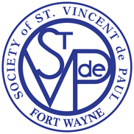
St. Charles Borromeo Conference of St. Vincent dePaul Society
4910 TRIER ROAD – FORT WAYNE

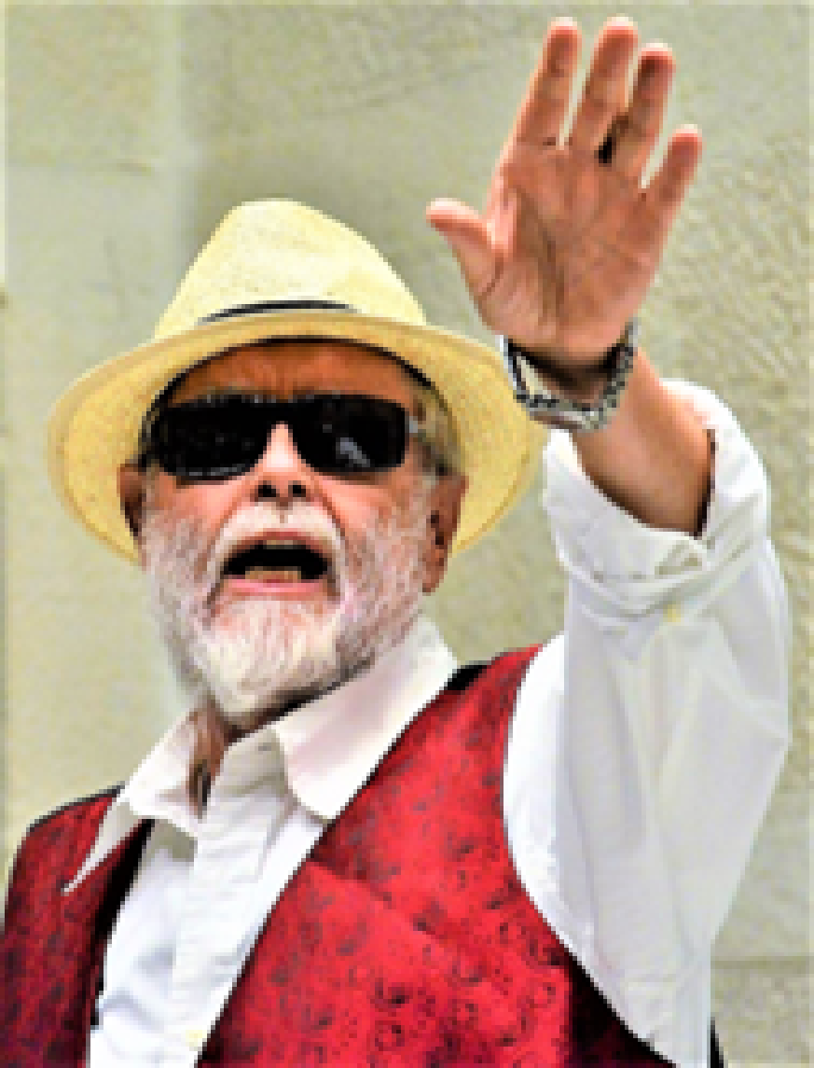
Presents
From Broadway to God!!
Featuring

Fr. John Sheehan, SJ
He’s a Singer! An Actor! A Priest!

Sunday, May 21, 2023 at 7:00 p.m.

Back by popular demand, Fr. John Sheehan will entertain us with a mix of religious and contemporary music and fascinating stories of his life and travels. Father Sheehan joined the Actors Equity, the professional theatre union, over 50 years ago. He has sung over 1,000 solo performances in 13 countries and in 15 different languages. Please plan to join us for a delightful evening of entertainment. Check out Youtube Fr. John Sheehan Sings If I Were A Rich Man.
A free-will offering will be accepted with all proceeds going directly to the St. Charles Borromeo Conference of St. Vincent dePaul Society to help those in need in our area.

Note: Cameras, cell phones and other recording devices are STRICTLY NOT ALLOWED!!!

St. Charles Borromeo Conference of St. Vincent dePaul Society
4910 TRIER ROAD – FORT WAYNE

Presents
From Broadway to God!!
Featuring

Fr. John Sheehan, SJ
He’s a Singer! An Actor! A Priest!

Sunday, May 21, 2023 at 7:00 p.m.

Back by popular demand, Fr. John Sheehan will entertain us with a mix of religious and contemporary music and fascinating stories of his life and travels. Father Sheehan joined the Actors Equity, the professional theatre union, over 50 years ago. He has sung over 1,000 solo performances in 13 countries and in 15 different languages. Please plan to join us for a delightful evening of entertainment. Check out Youtube Fr. John Sheehan Sings If I Were A Rich Man.
A free-will offering will be accepted with all proceeds going directly to the St. Charles Borromeo Conference of St. Vincent dePaul Society to help those in need in our area.

Note: Cameras, cell phones and other recording devices are STRICTLY NOT ALLOWED!!!

