Our Lady of Good Hope Lenten Fish Fry

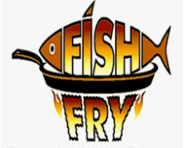

Friday, March 3rd, 2023
4:30 – 7:30 PM

Featuring:
Alaskan Pollock by Dan’s of Huntington
Tartar Sauce
Baked Potato
Dinner Roll
Applesauce

$12 DRIVE THRU ONLY

Knights of Our Lady
Council 12417

