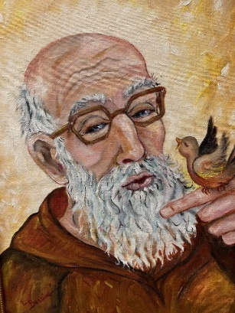
Will You Help Us ?
Try to recall the spirit of peace, holiness and love that one experiences at St. Felix Catholic Center--former home of Fr. Solanus Casey, in Huntington, Indiana.
Consider having the honor of sharing and practicing his spirituality by contributing to the creation of a Rosary Garden on the grounds of the monastery where he once walked in the garden—praying his rosary. Ponder the eternal value of spreading the devotion to Our Lady as Fr. Solanus did.
 Please send contributions to: Linda Leist | 3455 W. 600 N | Huntington, IN 46750-8891.

Reservation for Solanus Casey Center Pilgrimage on June 15, 2022

To further enhance our spirituality, we are offering the opportunity for a pilgrimage to the Solanus Casey Center in Detroit, MI, at the St. Bonaventure Monastery. Pray at his tomb where the miracle occurred leading to his beatification.
 YES, I would like to go on the special pilgrimage to Detroit to visit the Solanus Casey Center.
Name (please print) __________________________________ Email _______________________________
Address ______________________________ City __________________ State ___ Zip Code _________
Cell Phone (______) _______________________ Parish _____________________________________
Cost: $ 99.00 due by June 1, 2022.  After that date, Cost is $110.00
Includes: Round trip motorcoach transportation; Catered lunch in the dining room at the Shrine; 1.5-hour tour of shrine, and Mass. Complimentary bottled water, juice and donuts on the bus. Return trip dinner stop at Cracker Barrel is on your own. NOTE: No cancellations after 6 /1/22
☞ PICKUP LOCATIONS (select one)
 6:00 am SS Peter & Paul | 860 Cherry St | Huntington (near the school)
 6:30 am St. Elizabeth Ann Seton | 10700 Aboite Center Rd | Fort Wayne (SW corner near grotto)
 Please mail this form and your check payable to LINDA LEIST | 3455 W 600 N | Huntington, IN 46750

