JOIN US
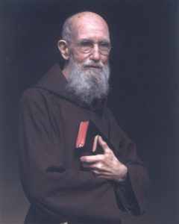
ST. FELIX CATHOLIC CENTER
1280 Hitzfield Steet
Huntington, IN 46750

SATURDAY, OCTOBER 16TH
12:30 p.m. Rosary
1:00 p.m. Mass for the Sick
Presider: Father Joe Tuscan

Following Mass:
Refreshments and Tours of St. Felix
Eucharistic Miracles – Exposition from the Vatican

2:30 p.m. Presentation by Father Joe Tuscan
Sponsored by
Praying With Father Solanus
https://www.prayingwithfrsolanus.org

