Eucharistic Miracles from the Vatican Exhibit
with
Quotes from Blessed Carlo Acutis

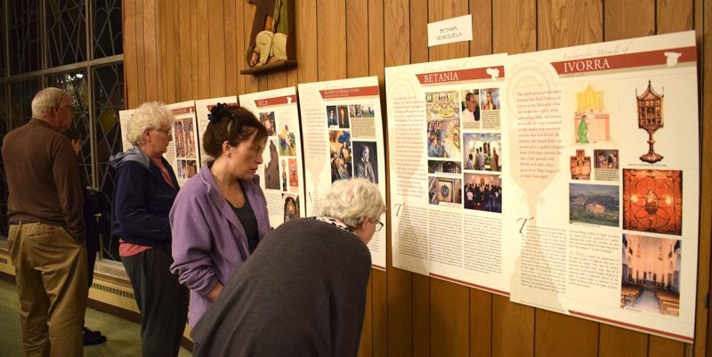

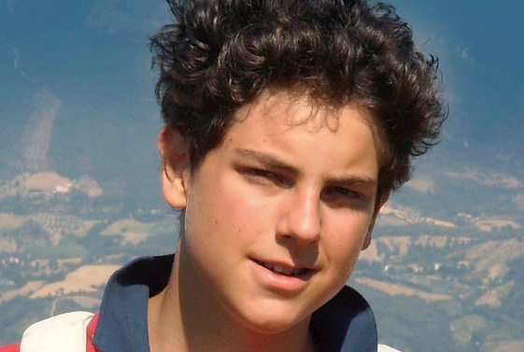
Option for talks on the miracles and on Blessed Carlo Acutis.

+ 48 Eucharistic Miracles Posters
​
+ Easy set up in parish hall, school auditorium
​
+ Children's coloring corner on Eucharistic
​
+ Information Scavenger Hunt on the Miracleso

+ Eucharistic Miracles Book, Biography of Blessed Carlo Acutis, related prayer cards

Contact the Confraternity of Penitents to schedule this free exhibit for your parish, school, group, or event. The exhibit works well in a parish center after weekend Masses.
Confraternity of Penitents, 1702 Lumbard Street, Fort Wayne IN 46803
Phone: 260-739-6882 Email: copenitents@yahoo.com

