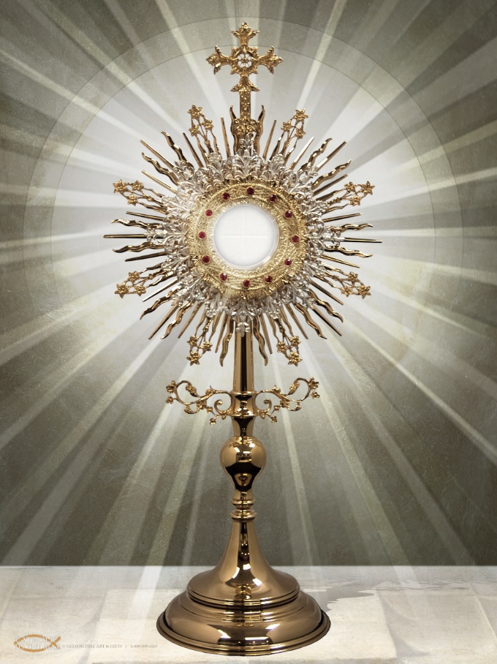
Our Lady of Good Hope
Corpus Christi Procession
June 6, 2021

Following 10:30AM Mass:
Exposition of the Blessed Sacrament until 3:30PM

Procession:
3:30PM around the parish grounds

Talk & Benediction:
At outdoor altar in the front lawn of the Church.

Conclusion:
Procession back in the Church where the Divine Praises will be prayed and Reposition will occur.

* First Communicants are invited to come in their attire and be in the procession before the Monstrance. They can also bring a basket with flower petals to toss in front of Christ during the Procession. *

(In the event of inclement weather, the talk and benediction will occur in the Church).

