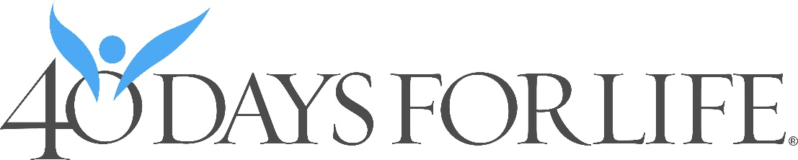

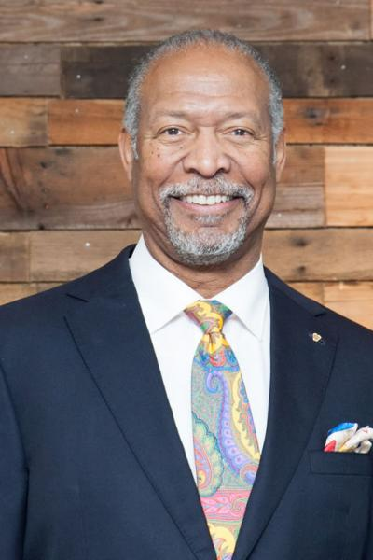

OPENING DAY PRAYER SERVICE
Wednesday, February 17th
We are pleased to announce that we will have our OPENING DAY VIGIL with special guest Dr. Haywood Robinson, a former abortionist. Dr. Robinson and his wife share their testimony nationwide to expose the facts of the abortion industry and to be a voice for the unborn. More about him here; https://www.ambassadorspeakers.com/speakers/unique/dr.-haywood-robinson Opening Day Vigil will be on site at Right-Of-Way in front of the Planned Parenthood between 5:30pm-6:00pm.

Address: 2930 Lake Avenue Fort Wayne, IN 46805
https://www.ichooselife.org/resources/events/upcoming-events/40-days-for-life

