Soup’s On!
Join us for a bowl of Ash Wednesday Soup
Your free will donation will help support
St. Mary’s Soup Kitchen
Which serves 600 free bowls of soup to hungry people every day.
Come Begin Lent Simply…
Bring a friend for a lunch of soup and bread on
Ash Wednesday
February 17, 2021
to St. Mary Mother of God Parish
11:30 a.m. – 1:30 p.m.
Oechtering Hall

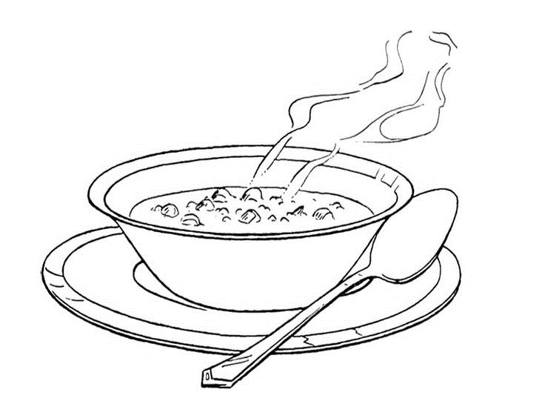
Lenten prayer service with ashes at 11:00 a.m.

Please follow COVID-19 Safety Protocols with regards to Social Distancing and Masks.

