# “No one who lights a lamp hides it away or places it [under a bushel basket],

# but on a lampstand so that those who enter might see the light.”-Luke 11:33

***MISSION POSSIBLE: HEALTHY MARRIAGES***

***LET’S PUT MARRIAGE (BACK) ON A LAMPSTAND!***

**February 9** | **3-7PM**

**St. Augustine Catholic Church**

1501 W. Washington Street, South Bend, IN 46619

*In the Community Hall.* *Use parking lot entrance. Limited Space. Registration required.*

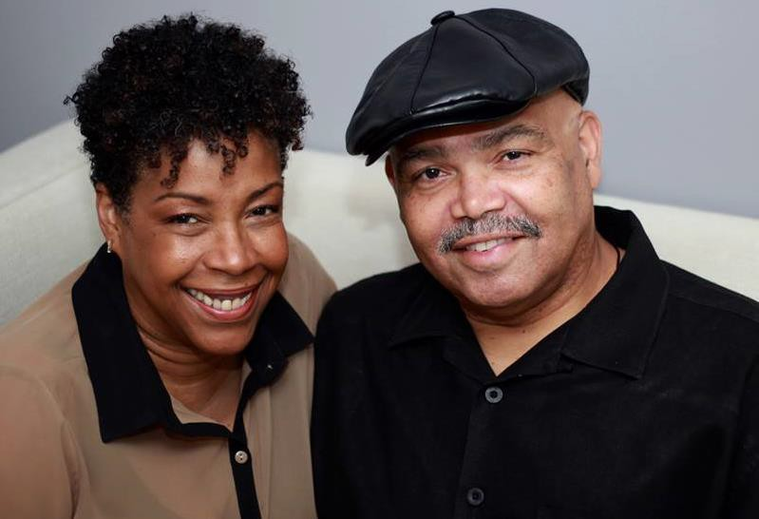



**FEATURING TERRI AND ANDREW LYKE, FROM JOLIET, IL**

# Authors of “Marriage on a Lampstand” / Founders of the Arusi Network ([www.arusi.org](http://www.arusi.org/))

­

**Registration Fee ($20.00 a couple)**

**Please confirm your registration by sending your name(s) and contact info to mtardy@nd.edu by January 31.**

* Come celebrate “National Marriage Week” (and an early Valentine’s Day)!!!
* Intentionally diverse gathering (ALL welcome!)
* Three keynote presentations: 1) The Gift of Marriage; 2) Modern Relationships: Challenges and Opportunities; and 3) Mission Possible: A New Paradigm for Today
* Especially welcome: married couples, dating couples, or those who minister to them
* Concludes with a candlelight dinner, cooked in-house by Chef Rex Marvel!

*­­*