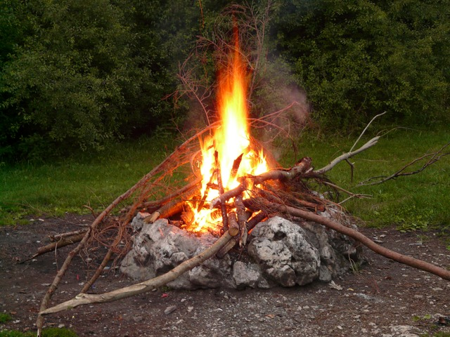

Join Fr. Andrew and other area Young Adults for dinner and a bonfire on **Friday, May 4, 2018**!

Are you looking for faith-filled friends to walk with you as you seek to follow Christ? Then come spend time with us, and lend your voice as we work to build a young adult community.

Mass is at 5:45, dinner and bonfire immediately following. Children welcome! Main meal provided, bring a side!

Questions?? Email Anne Therese Stephens, atsihm@yahoo.com

Bring friends – all young adults in the Fort Wayne area are invited!

### Mass at 5:45 Guerin Chapel, St. John the Baptist Parish

Bonfire and Dinner at the fire pit immediately after Mass.

“I have come to set the world on fire.”

~Jesus

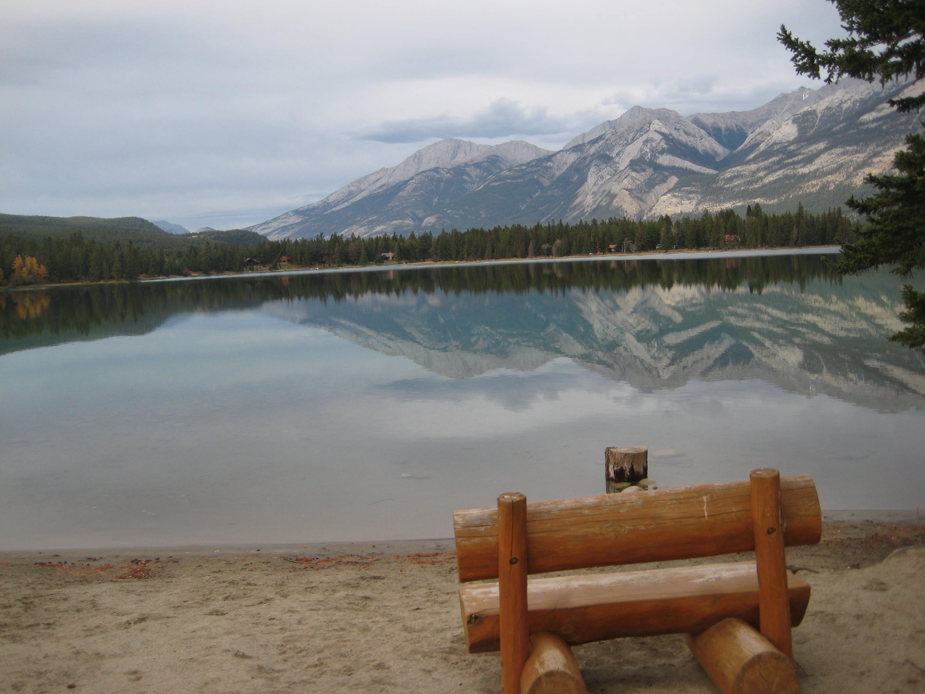

## Friday, May 4, 2018

4525 Arlington Ave

Fort Wayne, In 46807